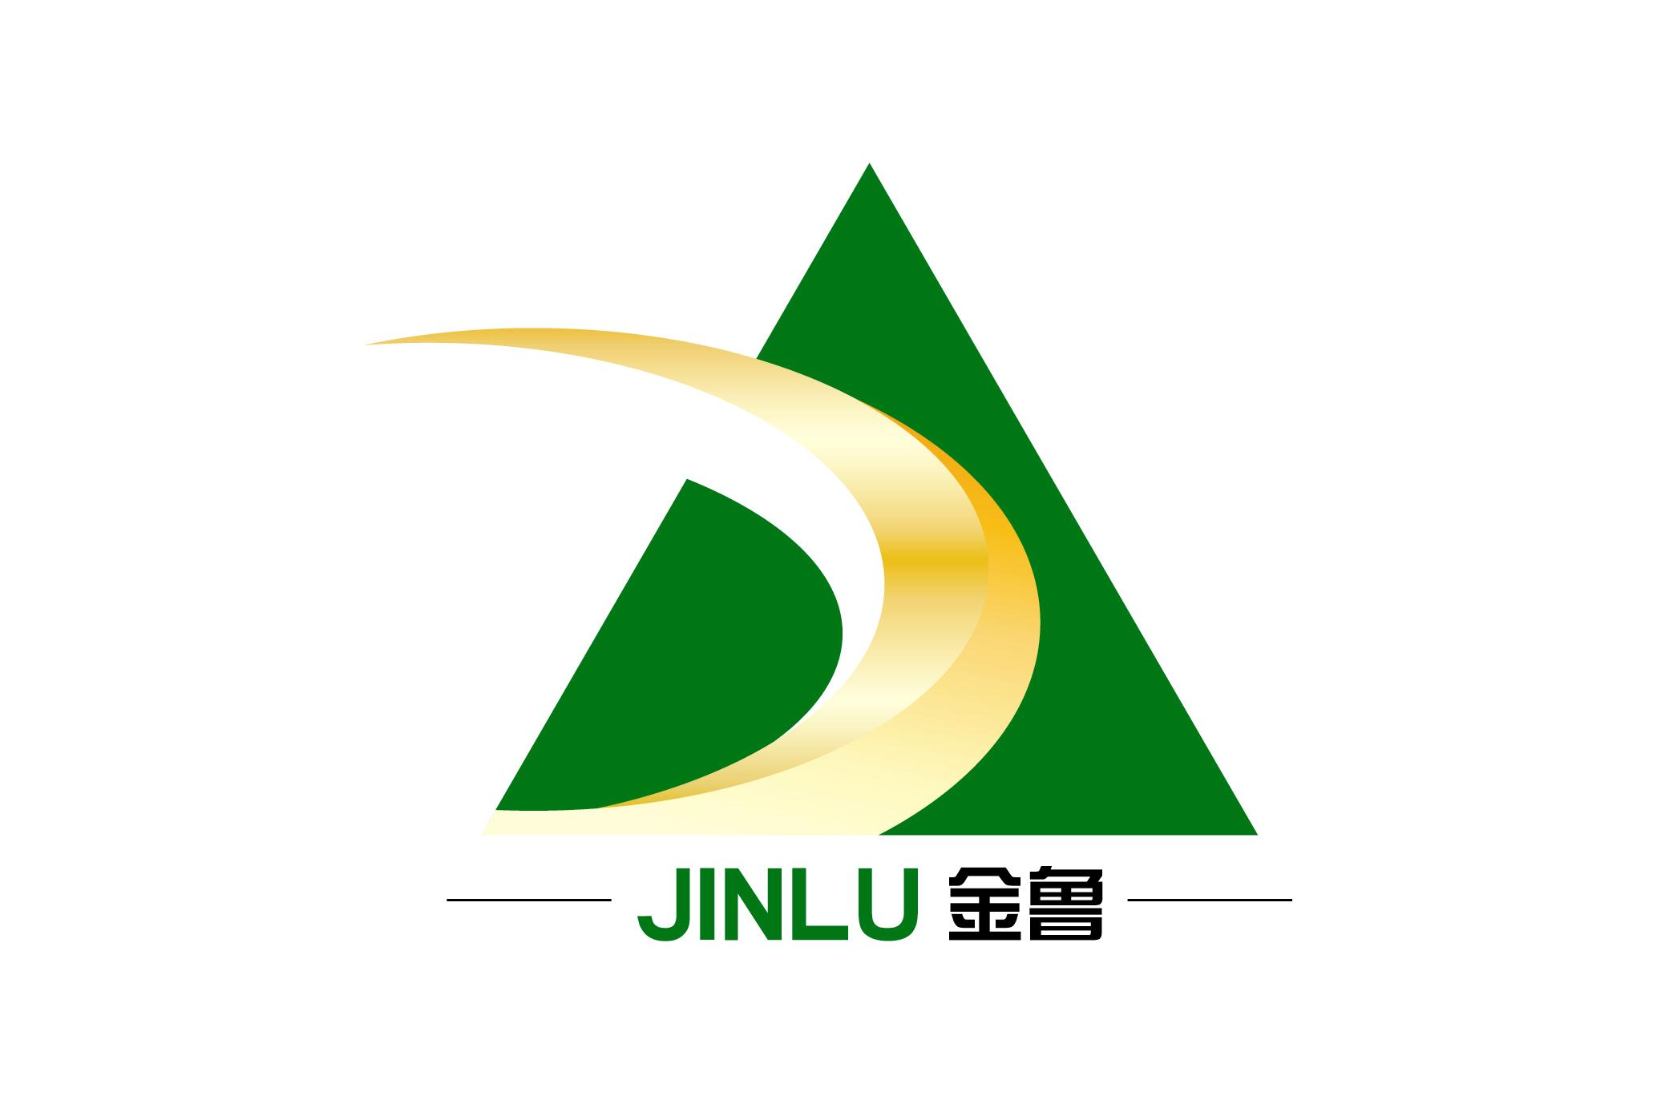
Jinlu Bio-Technology Product Series

Dispersing agent JL-WS
【Product outline】Dispersing agent ws is a kind of general type anionic dispersing agent.Though stabilizing the dispersion in dyes, this product can impove leveling of dyeing and dyefastness，prevent staining.This product do not have the ability of wetting and detergency, so it has affinity to animal fiber and nylon in acid medium. This dispersing agent suits for cotton, polyester and poly-cotton.

【Technical data】Appearance：Brown powder
Content：Aromatic sulfonic acid condensation objects

Ionicity: Anionic
【Characteristic】Stability： This product is acid-resistant, alkali-resistant and electrolyte-resistant even in high temperature dyeing condition.
Intermiscibility: Compatible with anionic and nonionic product. his product also can compatible with cationic product, just like Peregal P, but not available in neutral and acidic bath.
Solubility：This product can disslove in boiling water which 10-20 times than self-weight, or the same weight water pour into this product and stirring equality.10% this product is transparent in room temperature, and stable.
【Application】

Vat dye:
1、 Vat dye stock solution：
Vat dye 5-10g/l，dispersing agent WS can saliently improve the stability of the stock solution，this product should add before vat dyes.
2、jig dyeing：
2g/l，dispersing agent WS can improve the stability of dyeing bath，also can prevent acidity leuco body, just like use indanthrene.

3、cheese/bundle dyeing and rope dyeing：
1-3g/l，dispersing agent WS can prevent dye particle coalescence. Especially for Full suspension body and half suspension body dyeing process.
4、Rolling and steaming process：
2g/l, in the chemical groove,dispersing agent WS can prevent dye particle coalescence；After steaming，it is conducive to clear dyes which do not fix well；in vat dye oxidation bath, this product can prevent producing new insolubility dyes.

Disperse Dye
0.5-2g/l, dispersing agent WS can make dyestuff stable in dyeing process,the dosage depends on the dyestuff and its own dispersibility, in small bath ratio dyeing process, should increase the dosage.
5、Dispersing agent WS not only improve the stability of dyestuff, but also prevent surface dyeing gather in cooling process after dyeing process.

Washing process after printing

Disperse dye
6、In the washing process after printing of acetate fiber and nylon blend fabric, Dispersing agent WS can prevent disperse dyes contaminate nylon. Dosage is 1-1.5g/l

Cationic dye
7、Because of this product is affinity to cationic dye, Dispersing dye WS can be used for washing after printing process. Dosage is 0.5-1g/l
【Package and stock】 0-40℃ stock in closeness container，can stock 24month。

It is our sincerity to provide some technical advice and dosage in oral and written, but we don’t know your processing condition, so you must test all parameters prior to use it.

SHANDONG JINLU BIO-TECHNOLOGY INC.

Address:2139,Zhoulong Road ,Zhoucun,Zibo,Shandong,P.R. of China

Tel.:0086-533-6826888 6821888

Fax:0086-533-6821999

E-mail: jinluranliao@163.com

